Nettleton Parish Council - Safe access for pedestrians from Burton to Acton Turville.
Councillor: Chris Meier
Date: 06 /08/20 v 1.3 (FINAL)
Purpose : Walk children to attend School at Trinity infant and primary school.
Use tennis courts and sports facilities (football pitch and play area)
Use Post office and or Shop
Use the Pub (Fox and Hounds)
Visit friends or family
Fitness/leisure walk
Attend Church
Problems: There is not a continuous pavement between the two villages and there is considerable danger walking on the main road between the villages, particularly up “Hillside” as it joins “The Street” and heads up towards the motorway bridge. After the motorway bridge there is no designated pavement, walkway or footpath adjoining the road.
Assumptions: The existing cross-country footpath route is not suitable due to “mud and water logging in winter months.” The question is how many NPC councillors have walked this route?
A safe continuous pavement or footpath option alongside the main road is not viable due to a lack of willingness to cooperate from the land owners whose land would be affected.
Existing assets: Wiltshire Footpath ref NETT32, and South Gloucester Footpaths LAT6, LAT5 (part of)
This image shows the existing cross-country footpath route from Burton to Acton Turville. Once
across the Street in Burton there are no additional roads to cross before reaching Trinity school. The
route once over the M4 is through pasture and paddocks. At no point does the route cross
permanently boggy or waterlogged ground.
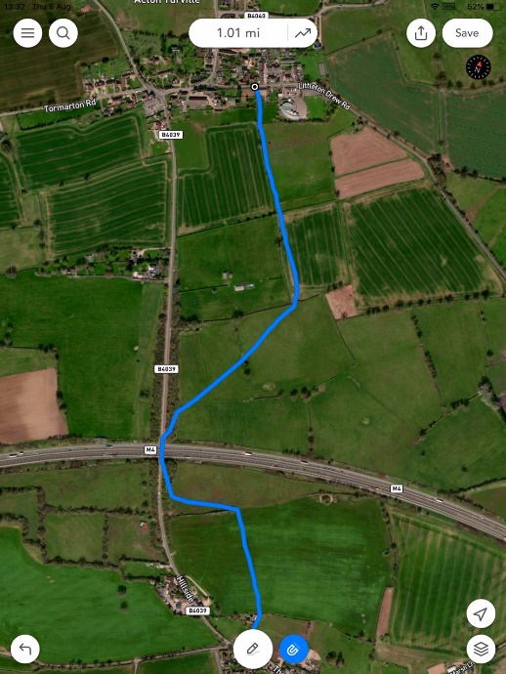

South Gloucester Footpaths LAT6, LAT5 (part of)
The road can be crossed at the Burton end on The Street with good sight lines and is within the
30mph zone of the village.
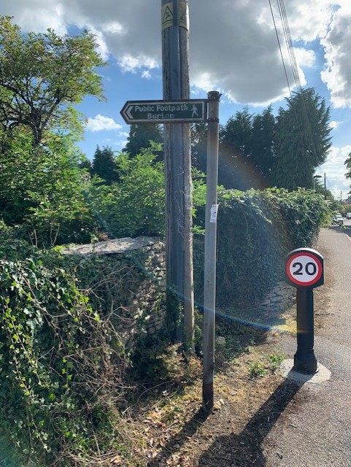
At the Acton Turville end the footpath comes onto (Littleton Drew Road) between the cross roads
and Trinity School onto a pavement.

Issues to address
LAT 6 access is blocked by an electric fence part way along (19/7/20) . Requires
ducking under.
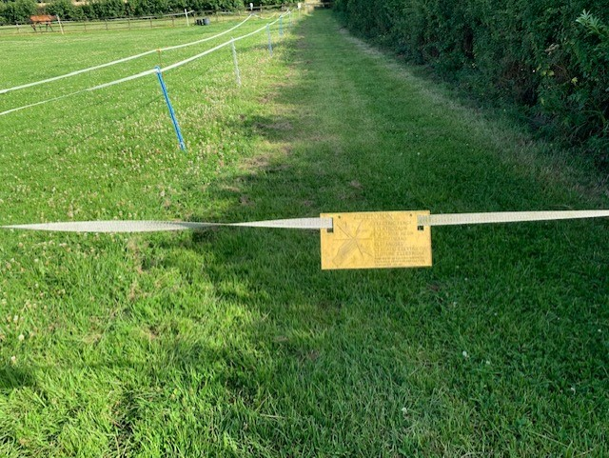
NETT32 access via a farm gate at top of drive is partly overgrown and needs overhanging foliage trimmed and also the gate is partly obstructed by a bin. There was also a heavy metal chair placed against the gate which stopped the gate being opened.
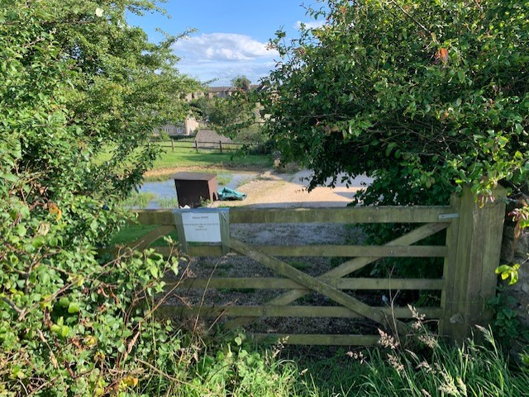

Footpath through the second field after the M4 bridge heading towards Burton Street is obstructed by a standing crop – no attempt has been made to provide a clear access as per the law regarding cross field footpaths.

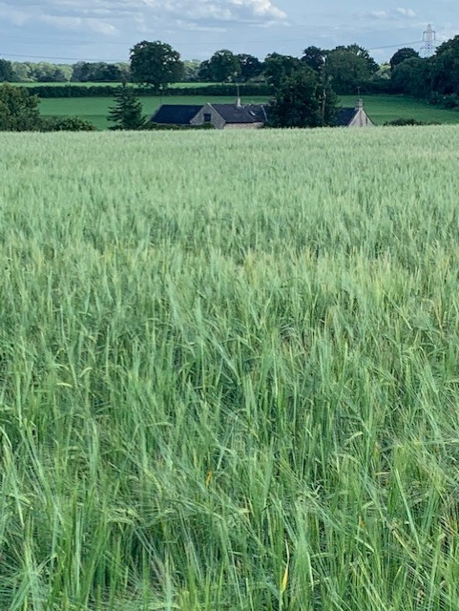

Style crossing from pasture to cropped field on Burton side of M4. The direction for traversing
field to gate exit could be improved . Stile is in good repair
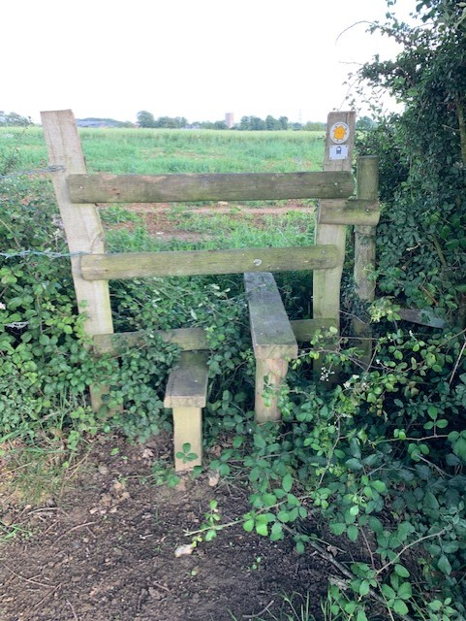

Gate from Acton Turville side of M4 from pasture onto the M4 foot bridge path – could do with
Repair.
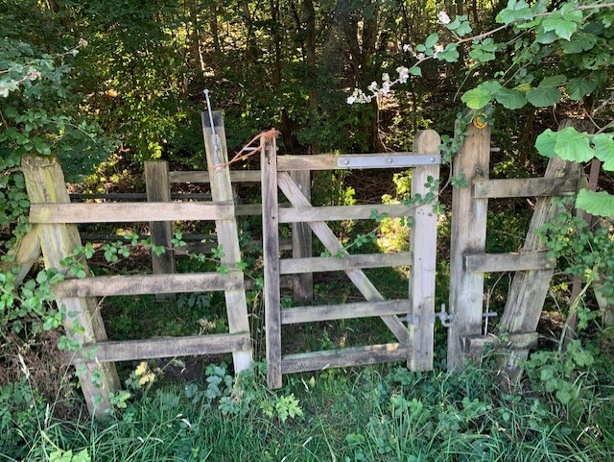

The whole bridge part of the footpath could do with brushing down and minor vegetation cut back
mainly on the bridge itself.
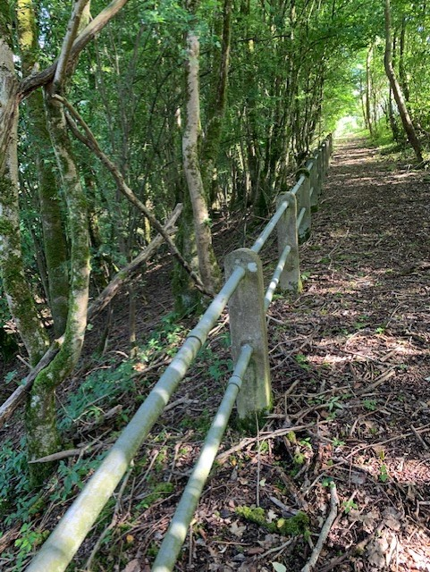

Further Actions proposed
- NPC need to reviews this proposal (13/8/20)
- Burton parents of Children at Trinity school should be asked for views ref attitude to walking to school.
- Burton Community Association could be asked to carry out some local resident surveys re walking to school and walking to the post office/ shop in Acton Turville.
- The landowner at the Burton end of NETT32 needs to be asked to make sure access to the Footpath via the gate is clear and unobstructed*. Field owner across which NETT32 traverses needs to be asked to comply with legal requirement to make footpath accessible when the field is under cultivation.
- Parish council responsible for LAT5 and LAT6 need to be engaged.
- Trinity school head teacher should be engaged too.
- Cotswolds wardens should be engaged re signage, stile/gate improvements and vegetation clearing

*A vehicle is often parked directly in front of the gate preventing its opening, perhaps a hybrid gate with a pedestrian access as well as large vehicle gate could be installed?

